
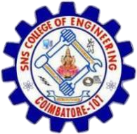
SNS COLLEGE OF ENGINEERING
Kurumbapalayam (Po), Coimbatore – 641 107
AN AUTONOMOUS INSTITUTION
Approved by AICTE, New Delhi and Affiliated to Anna University, Chennai

A MINI PROJECT REPORT

On

DINE LINE

in partial fulfilment for the award of the
degree of

BACHELOR OF ENGINEERING

in
COMPUTER SCIENCE AND DESIGN

Submitted by
Kirthik Kumar S (713323CD024) Koshika T (713323CD025) Mohammed Afsal B (713323CD029)

Academic year 2025-2026

BONAFIDE CERTIFICATE
Certified that this project “Dine Line” is the Bonafide work of “ Kirthik Kumar S (713323CD024), Koshika T (713323CD025), Mohammed Afsal B (713323CD029)” and they had carried out the project work under my supervision.

SIGNATURE SIGNATURE
Dr. B.Anuradha, M.S., Ph.D., Ms. A.Sunanda Christy, B.E.,M.E.,
Associate Professor & Head, Assistant Professor & Project Coordinator
Department of Computer Science and Design, Department of Computer and Design,
SNS College of Engineering, SNS College of Engineering,
Coimbatore – 641107 Coimbatore – 641107
Submitted for the practical Examination held on ………………

Internal Examiner External Examiner

Acknowledgement

First of all, we extend our heart-felt Gratitude to the management of SNS College of Engineering, for providing us with all sorts of support in completion of this project.

We wish to express our sincere thanks to Deivathiru Dr.S.N.Subramanian, Chairman/Founder Dr.S.Rajalakshmi, and Secretary /Technical Director Dr.S.Nalin Vimal Kumar those progressive ideas added with far sighted counsel has shouldered us to reach meritorious heights.

We are indebted to express our deep sense of gratitude to the Director Dr.V.P.Arunachalam, Principal Dr.S.Charles and Vice Principal Dr.R.Sudhakaran, for their valuable support while doing our project.

We highly in dept to record our sincere thanks to Dr.B.Anuradha, Associate Professor and Head, Department of Computer Science and Design, for her expert guidance, suggestions, and active encouragement for the fulfillment of the project work.

We would like to thank MrsA.Sunanda Christy, Project Guide, and our supervisor Mrs.Thasni Asharaf, Department of Computer Science and Design for their able guidance, without which, our project would not be a successful one.

We solemnly express our thanks to all the teaching and non-teaching staff members of the Department of Computer Science and Design, family and friends for their valuable support which energized us to complete our project in time.

TABLE OF CONTENT

S.NO. | TOPIC | PAGE NO.
1. | Abstract | 1
2. | Industrial Vertical & Domain Technology | 2
3. | Empathy | 4
4. | Define | 7
5. | Ideate | 8
6. | Prototype | 11
7. | Testing & Deployment | 17

Abstract

The Dine Line project addresses the pervasive issue of modern meal consumption, affecting individuals who seek both convenience and health. As busy lifestyles necessitate quick options, traditional food services often fail to meet the demand for nutritious, fresh, and familiar food. Recognizing these limitations, the Dine Line initiative proposes an innovative solution designed to help a company like Daily Harvest scale its meal delivery service while maintaining product quality and freshness. At the core of the Dine Line solution is a multi-faceted approach, combining advanced supply chain optimization with strict quality control. This logistical challenge is complemented by a deep focus on customer needs: food that is healthy, affordable, filling, and suited to Indian tastes, rather than "foreign" meal kits. The platform concept incorporates mechanisms to ensure reliability, freshness, and convenience, enhancing customer trust. The Dine Line strategy prioritizes balancing increased customer demand with limited supply chain efficiency, ensuring customers receive consistent meal experiences and empowering individuals to maintain a healthy diet without the burden of cooking or wastage.

In conclusion, the Dine Line project presents a comprehensive solution to the meal delivery service challenge by integrating strategic scaling and supply chain logistics with customer support mechanisms. By addressing the limitations of existing food delivery options and offering a versatile strategy tailored to high demand, Dine Line aims to promote healthy eating and convenience among its users. This innovative approach not only seeks to manage logistics but also fosters a proactive mindset toward consistent quality, making it a valuable resource in the growing meal delivery indust

Industrial Vertical and Domain Technology

Health Care:

The Dine Line project is positioned within the Food Technology and Meal Delivery industries, primarily focusing on supply chain optimization and maintaining freshness and quality. As the demand for convenient, healthy, and ready-to-eat meal options grows rapidly, companies like Daily Harvest face a challenge in scaling operations while ensuring product integrity. The platform offers a modern, technology-driven approach to meal delivery by combining efficient logistics with stringent quality control, which are critical factors for success in this industry. The solution addresses the challenge by implementing an advanced system to balance increased customer demand with limited supply chain efficiency, thus mitigating delays and inconsistent meal experiences.

By focusing on Food Technology, the project aligns with the industry's growing emphasis on reliable, temperature-sensitive logistics needed to handle perishable meals. This platform offers a scalable alternative to traditional food delivery methods, empowering the business to reliably deliver healthy, high-quality, and affordable meals that are culturally familiar to the target market. The project provides a fresh, data-driven solution that supports both operational scalability and customer satisfaction in the evolving Food Technology domain.

IOT (Internet of things):

This project leverages the power of IoT (Internet of Things) to create an efficient, data-driven system that offers a personalized and monitored approach to food quality and supply chain logistics. While the core platform manages orders and customer interactions, the accompanying mobile app provides supply chain managers and quality assurance teams with a variety of customizable, real-time metrics designed to support meal freshness and operational efficiency. Supply chain managers can monitor the temperature and location of perishable inventory using smart sensors, adjust delivery routes based on real-time traffic data, and receive automated alerts for deviations from ideal conditions, all accessible through the app.

By allowing stakeholders to engage with these elements, the platform fosters just-in-time inventory and reliability in a way that feels intuitive and adaptable to logistical needs. Whether the goal is ensuring vegetables remain below a critical temperature during transit or minimizing delivery time for meals, the platform offers a versatile suite of options managed through the app interface.

The integration of smart packaging and cold chain monitoring adds an additional layer of quality control, helping to uphold the product's freshness and encourage customer trust. While the platform relies on complex data analysis and real-time monitoring of physical assets, the app empowers managers to tailor the supply chain, giving them greater control over product integrity and fulfillment activities. This approach creates a reliable, scalable, and fresh environment for meal delivery.

Chapter 1

Empathy

An empathy map is a collaborative tool used to better understand a user's thoughts, feelings, behaviors, and needs. It provides a visual representation of a user's experiences, helping teams empathize with their challenges and motivations. By focusing on what the user says, thinks, does, and feels, the map captures key insights into their perspective. This process not only aids in identifying pain points and desired outcomes but also supports the creation of user-centered solutions. Empathy maps are widely used in design thinking, product development, and customer research to ensure a deeper connection with the user.
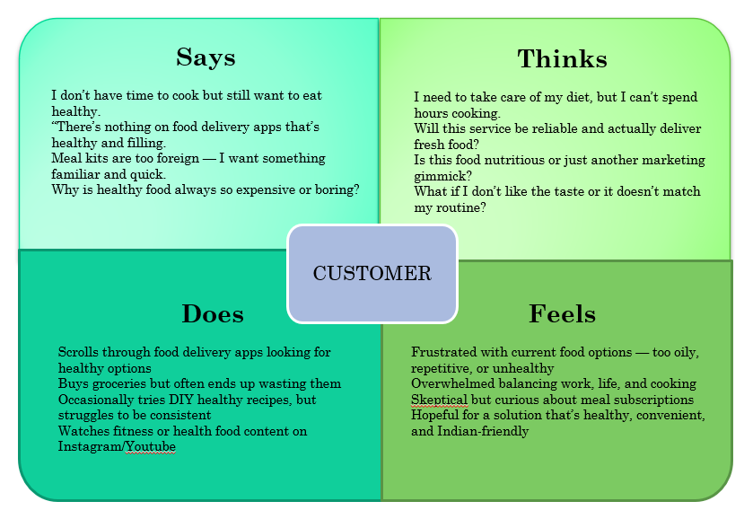
Fig.1.1 Empathy map

Says:
The customer clearly expresses a fundamental conflict: "I don’t have time to cook but still want to eat healthy." They vocalize their intense frustration with existing delivery options, complaining that, "There’s nothing on food delivery apps that’s healthy and filling." A key preference is for cultural familiarity, as they find meal kits to be "too foreign" and state, "I want something familiar and quick." Furthermore, they consistently question the value of current healthy eating options, asking, "Why is healthy food always so expensive or boring?" This indicates a need for a practical, affordable, and culturally appropriate solution.

Thinks:
Internally, the customer recognizes the necessity of diet management, acknowledging, "I need to take care of my diet, but I can’t spend hours cooking." A significant anxiety revolves around trusting a new meal service's execution, as they constantly wonder, "Will this service be reliable and actually deliver fresh food?" They are deeply skeptical about the nutritional claims, pondering, "Is this food nutritious or just another marketing gimmick?" They also worry about personal suitability and long-term commitment, wondering, "What if I don’t like the taste or it doesn’t match my routine?" This highlights a need for transparent reliability and customizable options.

Does:
The customer actively engages in attempts to solve their problem. They spend time scrolling through food delivery apps looking for healthy options, often without success. Despite their best intentions and initial purchases, they buy groceries but often end up wasting them due to lack of time or motivation to cook. They occasionally tries DIY healthy recipes but struggles to be consistent. Additionally, they watch fitness or health food content on Instagram/Youtube, indicating a high level of awareness about wellness trends.

Feels:
The customer feels a pronounced sense of Frustrated with current food options, describing them as too oily, repetitive, or unhealthy, which fails to meet their needs. This lack of viable options leaves them feeling Overwhelmed balancing work, life, and cooking, suggesting a strong emotional burden. While they express deep Skeptical but curious about meal subscriptions, they remain fundamentally Hopeful for a solution that's healthy, convenient, and Indian-friendly, which is a critical factor for adoption and sustained use.

Chapter 2

Define

The project, Dine Line, focuses intensely on addressing the critical and increasing challenges faced by the meal delivery service, Daily Harvest, in scaling its operations to meet high customer demand while rigidly maintaining product quality and freshness. In today’s rapidly growing meal delivery market, the core problem lies specifically in balancing increased demand with limited supply chain efficiency, which causes delays and inconsistent meal experiences for customers.

The project aims to design an innovative, technological solution that promotes reliability, consistent quality, and operational scalability for the entire meal delivery service ecosystem, recognizing the complexity inherent in managing production, inventory, and distribution of perishable goods. Dine Line envisions creating a strategic system that must solve the key challenge of designing a system that ensures reliability, freshness, and convenience for the end-user, while simultaneously being cost-effective and highly adaptable to the Indian market.

This dual focus is essential because customers are seeking affordable, healthy, and familiar meal options without the burden of cooking or the financial loss of food wastage. The ultimate goal of this project is to empower the service to manage increased demand effectively, streamline supply chain logistics, and, most importantly, maintain freshness, quality, and deep customer trust. This project aligns perfectly with modern approaches to tackling logistics, blending technology, design thinking, and empathy to create a robust system that truly caters to its users' needs while securing sustainable business growth.

Chapter 3

Ideate

The project Dine Line seeks to address the growing challenges of scaling a meal delivery service, focusing on maintaining product quality and efficiency while meeting increased customer demand. The core problem requires innovative solutions for supply chain management, quality assurance, and customer experience. Dine Line is designed as a technological solution that combines data-driven features to help the business scale effectively, ensure meal freshness, and build customer trust. Using modern web and mobile technologies, the platform will offer a user-friendly and engaging experience with various tools for logistics optimization and quality control.

Smart Cold Chain Monitoring (IoT Integration)
One of the core features of Dine Line will be Smart Cold Chain Monitoring, a technique essential for handling perishable meals. The concept involves using IoT sensors placed in packaging, storage units, and delivery vehicles to capture and transmit real-time temperature data. Engaging in this activity promotes strict quality control and reduces spoilage by helping managers focus on temperature-sensitive logistics. Dine Line will provide a dashboard where managers can interactively monitor the environmental conditions of all inventory in transit. This will not only allow the business to uphold the product's freshness but also prevent supply chain inconsistencies. JavaScript will be used to process and display the live sensor data, while CSS will style the dashboard for an intuitive and pleasant user experience.

AI-Driven Demand Forecasting
Accurate demand forecasting is critical for optimizing production, inventory, and distribution. Dine Line will feature an AI-driven forecasting model to evoke proactive planning and minimize food wastage. This model will use historical order data, seasonal trends, and current customer subscription rates to predict future meal demand with high accuracy. The data will be carefully selected to ensure the system efficiently manages production and minimizes excess inventory. The forecasting results will be displayed in a pleasant, easy-to-navigate interface, allowing managers to engage with the projections while ensuring all logistics are prepared for increased volume.

Personalized Indian-Friendly Menus
Personalized Indian-Friendly Menus are a powerful tool for building customer loyalty and addressing the frustration with repetitive or foreign options. By reinforcing familiar and nutritious meal options, the platform helps combat customer skepticism. Dine Line will feature daily or weekly meal plans such as “South Indian Thali,” “North Indian Meal Box,” or "Protein-Packed Indian Breakfasts." These menus will be dynamically generated using JSON to ensure they are personalized based on the user’s preferences, dietary restrictions, and regional tastes. JavaScript will handle the interaction, allowing customers to easily select and customize their meals, helping them maintain a healthy and satisfying routine.

Optimized Delivery Route Planning
Efficient Delivery Route Planning has long been recognized for its role in ensuring meal freshness and reliability. Dine Line will include an integrated tool for generating optimized delivery routes, which accounts for traffic, delivery windows, and the temperature data from the cold chain. Users (delivery managers) will have the option to view these routes while engaging with other features on the site. JavaScript will be responsible for controlling the map visualization and integrating real-time traffic updates. The route optimization will be embedded into the platform, providing seamless integration with the user interface.

Technological Implementation
The solution, accessed via a dedicated app, will be built using HTML (for the basic structure), CSS (for styling and ensuring a professional, scalable design), and JavaScript (for all interactivity, including IoT data visualization and route optimization). JSON will be used to manage data such as menu items, user preferences, and real-time sensor readings. This combination of technologies will create a seamless, engaging, and effective platform for both managers seeking operational control and customers seeking fresh, reliable meals.

Chapter 4

Prototype

The prototype for Dine Line serves as a tangible representation of the envisioned meal delivery application. It showcases the platform’s core functionalities, including the Email OTP authentication system, advanced meal filtering, the shopping cart with real-time management, and the complete checkout flow, all designed to promote convenience and build customer trust. Built using a modern stack—incorporating React, Zustand for state management, and a custom database integration—the prototype highlights the user-friendly, responsive interface and the seamless integration of nutritional data. The prototype offers a glimpse into the personalized experience the app aims to provide, enabling customers to easily discover nutritious, Indian-friendly meals and place reliable orders in an engaging environment. This serves as a foundation for future development and refinement, particularly in integrating real-time logistics data.

Program:
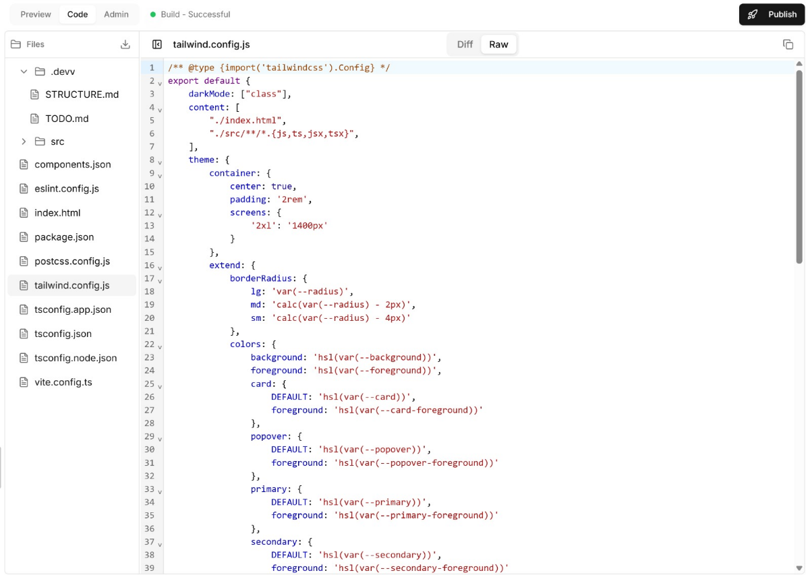
Fig.4.1 Program code

Prototype:
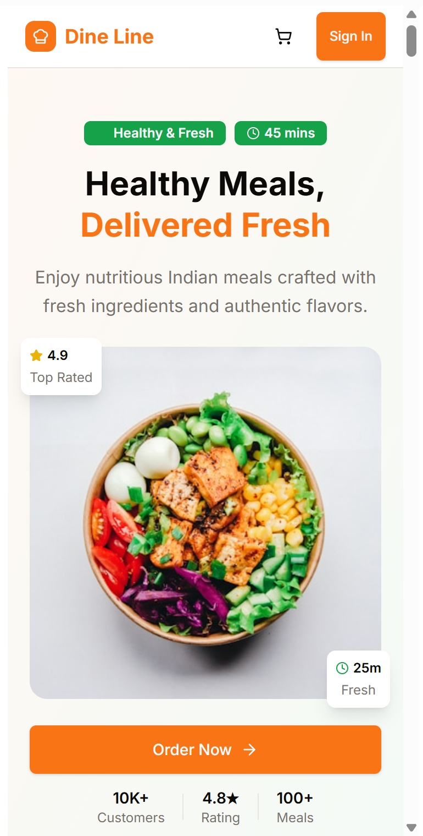
Fig.4.2 Prototype

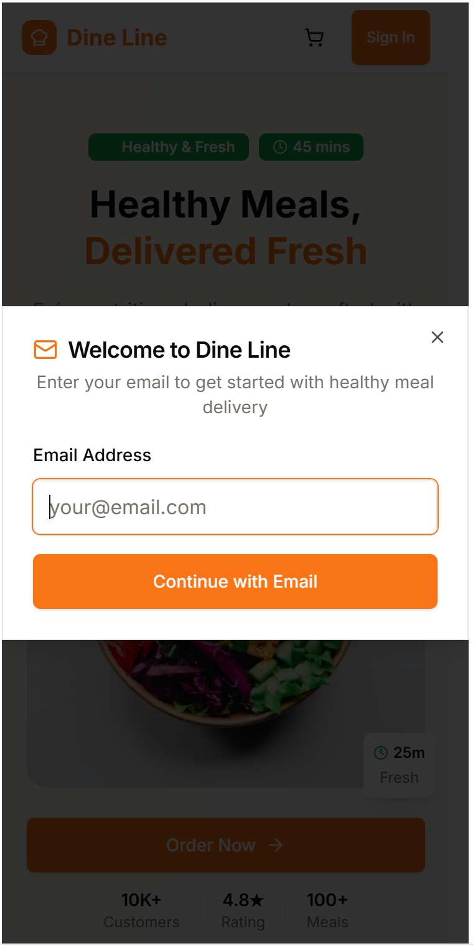
Fig.4.3 Prototype

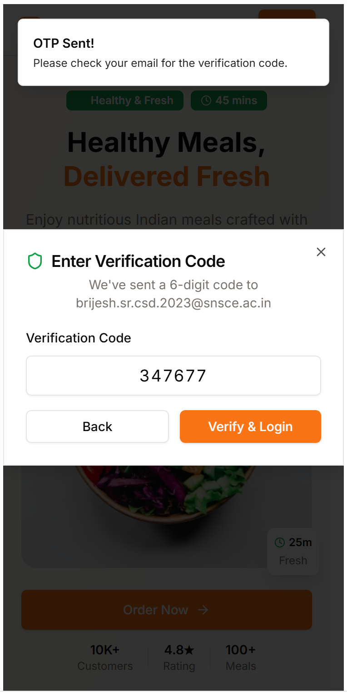
Fig.4.4 Prototype

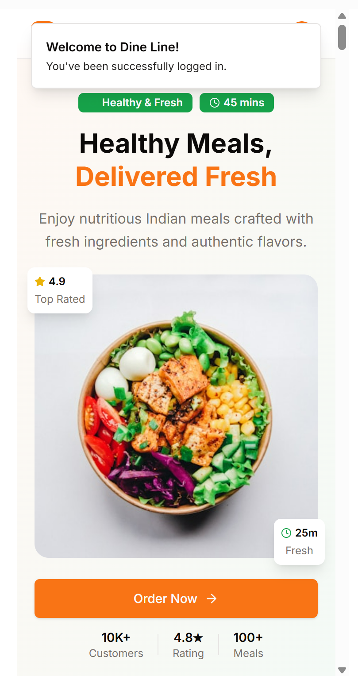

Fig.4.5 Prototype

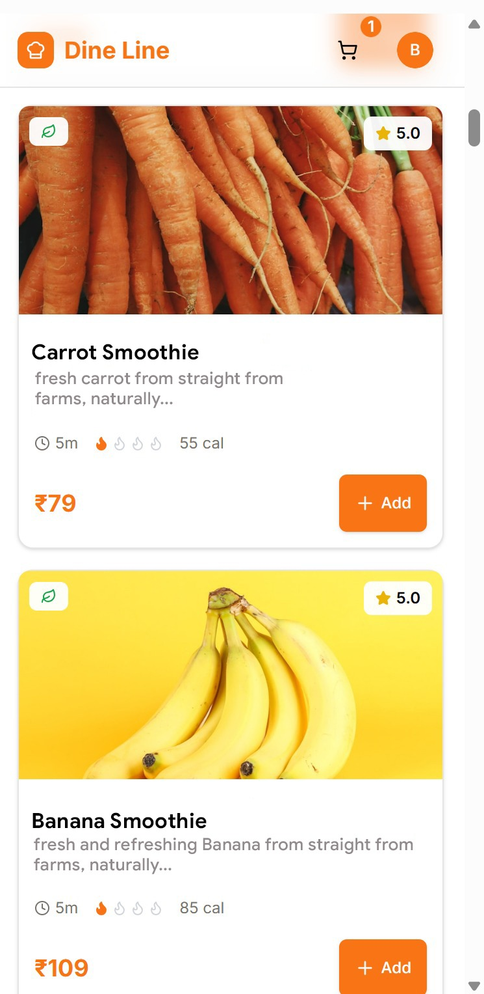

Fig.4.6 Prototype

Chapter 5

Testing & Deployment
Data Testing:
The prototype data testing phase for Dine Line focuses on evaluating the integrity and consistency of its core data features, such as demand forecasting, menu customization, and real-time inventory status. Specifically, for the AI-Driven Demand Forecasting model, testing involves verifying the accuracy of predictions against historical sales data and seasonal trends, ensuring the model's reliability in optimizing production volumes. Feedback will be collected to assess usability, including how effectively managers can interpret and utilize the forecasting dashboard. Other components, like the menu item nutritional data and customer subscription information, will be tested for data correctness and seamless retrieval. This phase ensures all data inputs and outputs perform optimally, providing a trustworthy foundation for logistical decision-making and a transparent customer experience.

Real-time Testing:
The prototype testing for Dine Line focuses on evaluating the real-time functionality and effectiveness of core features like Smart Cold Chain Monitoring and Optimized Delivery Route Planning. The aim is to ensure smooth data interactivity, system responsiveness, and logistical impact. Field teams will test the Cold Chain Monitoring system by simulating temperature deviations, while the app's accuracy in generating automated alerts and displaying live temperature maps will be monitored. Real-time tracking of drivers and the synchronization of order fulfillment with inventory levels will be assessed for seamless integration and operational efficiency. This testing phase ensures the prototype meets its goals of scalability, reliability, and guaranteed meal freshness.

Conclusion:
In conclusion, Dine Line is an innovative and thoughtfully designed solution aimed at providing a holistic approach to meal delivery through strategic, data-driven, and quality-focused features. Scaling meal delivery operations while maintaining product freshness has become an unavoidable challenge of the modern food industry, often affecting customer trust and business growth. Through key solutions such as Smart Cold Chain Monitoring, AI-Driven Demand Forecasting, and Personalized Indian-Friendly Menus, Dine Line offers a comprehensive toolkit to combat supply chain inefficiency and quality inconsistency effectively. By integrating these technological elements into a single system, the project ensures operational scalability, reliability, and a superior customer experience.
Real-time prototype testing will play a critical role in validating the effectiveness of the logistics features and gathering performance data. This iterative process ensures that the final system not only meets technical standards but also fulfills its purpose of guaranteeing meal freshness and delivery accuracy. The testing phase will assess real-time data flow, system responsiveness, and the impact of route optimization, leading to continuous improvements.

Overall, Dine Line stands out as a powerful solution for scaling meal delivery, combining logistics, technology, and customer empathy in an engaging platform. By addressing the diverse operational and consumer needs, the project contributes to improving food quality and market reach. The success of Dine Line lies in its ability to integrate technology with supply chain best practices, providing a valuable tool for businesses to manage growth effectively and enhance their overall quality of service. This project demonstrates the potential of technology-driven solutions in fostering reliable food technology platforms.
.

Future Enhancements:
As part of Dine Line's ongoing development, several future enhancements are envisioned to make the platform more dynamic, personalized, and impactful for meal delivery and operational management. One key improvement involves integrating innovative AI-driven personalization technologies. By incorporating advanced machine learning algorithms to analyze user history, dietary goals, and meal rating feedback, the app can predict individual meal preferences and subscription needs, offering highly personalized recommendations instead of static, pre-set meal options.

For example, during periods of peak subscription (e.g., New Year's resolutions), Dine Line could automatically suggest nutritionally balanced meals that align with a customer’s weight goals, or during regional holidays, it might suggest engaging with specific celebratory Indian menus. This adaptive functionality ensures that customers receive meal interventions tailored to their current lifestyle and evolving palate.

To further enhance the app's utility, Supplier Gamification and Optimization could be introduced. This could involve interactive performance scorecards or rewards for consistent on-time delivery and high-quality ingredient sourcing, encouraging suppliers to maintain best practices regularly. The platform may also expand its database to include real-time ingredient tracking from farm-to-kitchen using blockchain technology, empowering customers with complete transparency on the origin and freshness of their food. These enhancements aim to establish Dine Line as a cutting-edge meal delivery solution, continually adapting to operational needs while moving beyond simple delivery to offer innovative, technology-driven food quality and customer experience management.

External Source

https://www.binarysemantics.com/blogs/iot-based-cold-chain-monitoring/

https://www.mealtrack.com/blog/tf-083-ai-in-the-kitchen-how-technology-is-shaping-the-future-of-meal-planning-and-delivery

https://www.researchgate.net/publication/388425451_Real-Time_Supply_Chain_Resilience_Predictive_Analytics_for_Global_Food_Security_and_Perishable_Goods

https://www.ijfans.org/uploads/paper/3c48c71e0f45809131056d48ba9b9745.pdf

https://iot.telenor.com/iot-use-cases/cold-chain-management/

https://www.loginextsolutions.com/blog/when-every-second-counts-ai-route-optimization-for-same-day-and-instant-deliveries

https://www.mdpi.com/2071-1050/12/8/3497

